TECHNICAL DATA SHEET

APPLICATION PRACTICE OF THE NANOCERAMIC MATERIAL
FOR ENERGY SAVINGS

ThermX is a composite material that functions as a thermal and water barrier membrane. It is based on nanoceramic technology and includes specialized additives—bioprotective, anti-reactive, and antifreeze agents.
Styrene-acrylic latex is used in the composition as a binding element to achieve the specific characteristics of a membrane. The styrene component (approximately 20%) contributes to hardness, while the acrylic component (approximately 80%) provides elasticity and resistance to weathering.
The membrane exhibits all the typical properties of an acrylic binder, including high resistance to climatic conditions (with a durability guaranteed by the manufacturer of at least 20 years), 12% elasticity, and strong adhesion to all surfaces—except those that are greasy or Teflon-coated. It also demonstrates a hardness of approximately 0.4 N/m², which is superior to that of standard acrylates (0.2 N/m²) and most enamels (0.1–0.3 N/m²).
The ceramic filler consists of microspheres filled with rarefied gas, comprising approximately 75% of the volume of the dried material. This component is primarily responsible for its high thermal insulation performance.
The material also contains bioprotective additives, including biocides, preservatives, and antifungal agents. These additives prevent fermentation, extend the product’s shelf life, and inhibit fungal growth on the applied surface.
As a water-based formulation, the material is classified as an ecological product and does not contribute to environmental pollution.

THE WORKING PRINCIPLE OF THERMX
The thermophysical properties of ThermX differ substantially from those of traditional thermal insulators.
As is known, the process of heat transfer in nature occurs through a multitude of physical phenomena:
- by thermal conductivity of the material itself;
- by convective heat exchange;
- by radiation.
Therefore, the resulting thermal conductivity of any physical body is determined as the sum of these three components.
ThermX is a capillary and porous material, with its interstitial space filled with ceramic microspheres in a non-energized (static) state. The gas contained within these microspheres exhibits negligible thermal conductivity. During the heat transfer process, energy is first absorbed by the outer wall of a microsphere, then gradually transferred to the gas inside, followed by the opposite wall, and subsequently to adjacent microspheres. At each stage of this transfer, energy losses occur.
In addition to reducing thermal conductivity, ThermX also exhibits resistance to infrared (IR) radiation. It possesses the ability to absorb, emit, and disperse IR radiation—an essential property that fundamentally alters the heat loss dynamics of a coated surface. Typically, surface heat loss comprises two main components: convective losses due to air surrounding the surface, and radiative losses resulting from “re-illumination” of the surface by both sides of the ThermX membrane.
As a result of its IR-resistant properties, the thermal emission coefficient of ThermX (1.29–2.2 W/m²·°C) is significantly lower than that of conventional construction and thermal insulation materials, which range from 9 to 23 W/m²·°C.
Alongside its high-tech advantages, ThermX has properties that are practically not found together in a single material:
- thermal insulation;
- impermeability;
- anti-corrosive protection.
Research into the efficiency of liquid ceramic thermal insulation (LCTI) presents certain challenges. Ultra-thin thermal insulation materials have not yet been incorporated into existing design and construction standards (such as СНиП or GOST). Additionally, standardized research methodologies and appropriate measuring equipment for evaluating such materials are currently lacking.
The optical properties of ThermX are characterized by distinct coefficients of absorption, reflection, and radiation, which differ significantly from those of black metals, conventional construction materials, or standard thermal insulation products. As a result, heat flux sensors used in technical control applications require special calibration due to the high reflectivity and very light coloration of the ThermX coating.
These factors can introduce substantial measurement errors when using sensors calibrated exclusively with “black body” radiation sources, which typically assume an emissivity close to 0.99 and operate within the 7–18 µm spectral range. Surface temperature measurements taken without applying specific methodological corrections—and without using appropriate optical filters in the pyrometer—can lead to considerable inaccuracies in the final readings.
At the same time, studies conducted on ThermX have demonstrated high energy-saving efficiency when target temperatures were maintained after applying ThermX layers of varying thicknesses to building envelope components. According to the findings:
- 0.25 mm layer reduces heat loss by approximately 15%.
- 0.5 mm layer provides energy savings of around 25%.
- 1 mm layer offers savings of up to 40%.

TECHNICAL SPECIFICATIONS OF THERMX
NAME | UNIT OF MEASURE | VALUE
Thermal conductivity at 20°C, max | W/ m°K | 0,001
Density in dry state | kg/m³ | 380-410
Density in liquid state | kg/m³ | 470-590
Vapor permeability coefficient | mg/ m h Pa | 0,0014
Specific heat capacity | kJ/kg °C | 1,08
Temperature resistance up to 230°C |  | No cracks, swelling, or delamination
Water absorption | g/cm³ | 0,03
Maximum relative elongation at break | % | >12
Maximum relative elongation at break after accelerated aging (10 years) | % | >12
Linear elongation | % | 65
Minimum breaking strength:  - with metal  - with concrete  - with wood | Mpa | 1,53  1,84  1,84
Minimum tensile strength:  - after application  - after accelerated aging (10 years) | Mpa | 2,0  3,0
Impact resistance | Kg/cm | 50
Whitening degree (% diffuse reflection):  - after application  - after accelerated aging (10 years) | %  % | 93,0  90,0
Transport and storage temperature | °C | + 5
Surface temperature during application | °C | de la + 1 la +150
Operating temperature | °C | de la - 60 la 230

ENERGETIC

Calculation formulas for flat, smooth walls are significantly simpler than those for cylindrical surfaces. In practice, formulas for flat walls can generally be applied when the diameter of the cylindrical object exceeds 2000 mm. Given that the thickness of ThermX insulation ranges from 0.5 to 3.5 mm, it is reasonable to use flat wall calculation methods even when applying ThermX to cylindrical structures.

Specifically, the calculation of the thickness of the ThermX thermal insulation layer on hot surfaces should be done according to СНиП 41-103-2000 in Russia, using the following formulas:

- Formula for the thickness of the ThermX insulation layer:

$$δ_{ThermX}=\frac{λ_{ThermX}⋅(T_{H}​-T_{0})}{α_{ThermX}^{(1,2)}⋅(T_{n}​-T_{0})}$$
where
$δ_{ThermX}$​ = thickness of the ThermX insulation layer (m)
$λ_{ThermX}$​ = thermal conductivity of the ThermX material (W/m·°C)
$T_{H}$​ = temperature of the heat agent inside the pipe or system (°C)
$T_{0}$​ = ambient (outside) temperature (°C)
$T_{n}$​ = desired temperature of the pipe’s outer surface (°C)
$α_{ThermX}^{(1,2)}$​ = heat transfer coefficient by radiation and convection of the ThermX layer (W/m²·°C)

- Formula for the heat flux through a surface covered with ThermX:

$$Q=α_{ThermX}^{(1,2)}⋅(T_{n}​-T_{0})$$
where
$Q$ = heat flux density (W/m²)
$T_{0}$​ = ambient temperature (°C)
$T_{n}$​ = desired temperature of the outer surface of the pipe (°C)
$α_{ThermX}^{(1,2)}$​ = heat transfer coefficient by radiation and convection of the ThermX layer (W/m²·°C)

Alternatively — General formula for heat flux with multiple resistances in series (radiation, ThermX, additional layer P):
$$Q=\frac{T_{n}​-T_{0}}{\frac{1}{α_{B}}+\frac{1}{α_{ThermX}^{(1,2)}}+\frac{δ_{P}}{λ_{P}}}$$
where

$α_{B}$​ = heat transfer coefficient by convection from the outside (W/m²·°C)
$δ_{P}$​ = thickness of the additional layer (e.g., polyurethane) applied over ThermX (m)
$λ_{P}$​ = thermal conductivity of the additional layer (W/m·°C)
The required thickness of the ThermX layer depending on the temperature of the thermal agent.

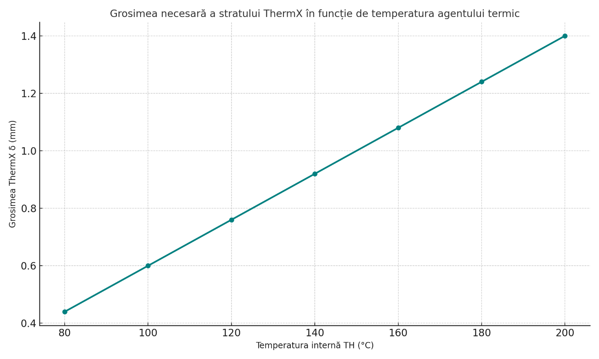
Internal temperature TH (°C)
ThermX layer thickness $δ (mm)$

During the calculation of the insulation thickness on objects located indoors, the ambient temperature must be between +18°C and +20°C.
For outdoor objects, the ambient temperature should correspond to the average annual temperature of the respective region.
Calculation Methods for ThermX Coating Thickness on Cold Surfaces (for preventing condensation and ice formation):
As practice shows, the higher the air humidity in a room, the thicker the insulation needs to be.
However, there are conditions in which eliminating condensation or ice on the surface of the object becomes impossible. Such conditions occur when the temperature difference exceeds 35°C and the air humidity is higher than 70%.
The following formula is used to calculate the minimum required thickness of the ThermX insulation layer in order to avoid condensation on cold surfaces (e.g. pipes, tanks, tubing, etc.).
The difference between temperatures Tₒ and Tₕ, as well as their ratio, determines how thick the insulation needs to be to prevent reaching the dew point, and thus, condensation.
$$δ_{ThermX}=\frac{λ_{ThermX}}{α_{ThermX}}\left(\frac{T_{o}​-T_{h}}{T_{o}​+T_{h}}\right)-1$$

where:

δ = - thickness of the ThermX insulation layer (mm);
λ_{ThermX} = 0,001 W/m·K - thermal conductivity of ThermX (W/m·K);
α_{ThermX} = 1,29 (interior) or 2,2 (exterior) - Thermal transfer coefficient of ThermX on the
surface (W/m²·K)
T_{h} - Temperature of the insulated surface (°C);
T_{o} - Ambient air temperature (°C).

Estimated period (Tₙ - T) is defined according to the following table:

T_{o} ,℃ | RELATIVE HUMIDITY OF THE AIR
 | 40 | 50 | 60 | 70 | 80 | 90
10 | 13,4 | 10,4 | 7,8 | 5,5 | 3,5 | 1,6
15 | 14,2 | 10,9 | 9,1 | 5,7 | 3,6 | 1,7
20 | 14,8 | 11,3 | 8,4 | 5,9 | 3,7 | 1,8
25 | 15,3 | 11,7 | 8,7 | 6,1 | 3,8 | 1,9
30 | 15,9 | 12,2 | 9 | 6,3 | 4 | 2

This heatmap shows the estimated period (Tₙ - T) depending on ambient temperature (T_{o}) and relative humidity. Lighter colors indicate higher differences and darker colors lower ones.

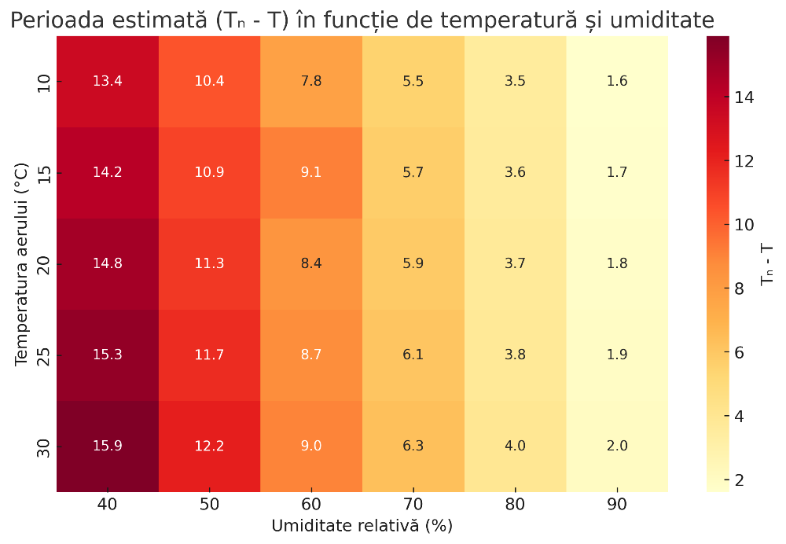
Relative humidity (%)
T_{n} - T
Air temperature (°C)

Technical Interpretation:
- Tₒ ​ is the exterior air temperature (°C).
- Tₙ - T represents the estimated difference between the dew point temperature (Tₙ) and the actual temperature of the insulated surface (T). This difference helps determine the condensation risk.
- The table values indicate this difference depending on air temperature and relative humidity.
- The smaller the value, the higher the risk of condensation, which means more efficient insulation is required.
- Example: At 20°C and 80% humidity, the value is 3.7, so the Tₙ - T difference is small and condensation risk is high.
In general, insulation thickness calculations are performed according to the СНиП 41-103-2000 standard, using the following formula:
$$δ=\frac{λ}{α}\left(\frac{T_{n}-T_{H}}{T_{n}​-T}\right)$$

Oil and Gas Industry
ThermX can be effectively used for the thermal insulation of oil and gas pipelines, including both above-ground (surface-mounted) and underground installations. The overall cost of applying ThermX is approximately 30% lower compared to conventional materials such as mineral wool and polyurethane foam. Additional savings are achieved through reduced energy losses during operation—up to 40%.
Specifically, the calculation of the ThermX insulation thickness on hot surfaces, based on the typical formula used in the USA (simplified for insulated pipes), is done using ASTM/ASHRAE standards and the following formulas:
$$Q=\left(\frac{T_{s}-T_{a}}{R_{t}​}\right)$$
where:
$Q$ = Heat flux (W/m²)
$T_{s}$​ = Surface temperature (°C)
$T_{a}$​ = Ambient air temperature (°C)
$R_{t}$ = Total thermal resistance of the insulation layer (m²·K/W)
Step 1: Calculate total thermal resistance$R_{t}$​:
For a cylindrical insulation (pipe):
$$R_{t}=\frac{1}{2_{πκ}L​}⋅ln\left( \frac{r_{2}}{r_{1}}\right)$$
where:
$κ$ = Thermal conductivity of the insulating material (W/m·K)
$L$ = Length of the pipe (m)
$r_{1}$ = Outer radius of the pipe (m)
$r_{2}$ = Outer radius of the insulation (m)

Step 2: Calculate required insulation thickness (pipe case)
If the maximum allowed heat flux $Q_{max}$ is known, the formula can be rearranged:
$$ln\left( \frac{r_{2}}{r_{1}}\right)=\frac{Q⋅2_{πk}L}{T_{s}-T_{a}​}⟹r_{2}=r_{1}⋅exp\left( \frac{Q⋅2_{πk}L}{T_{s}-T_{a}}\right)$$
insulation thickness:
$$δ= r_{2}-r_{1}$$
Short example in U.S. system (approximate values):
Thermal conductivity: = 0.001 W/m·K

$$T_{s}=150°C,T_{a}=25°C$$
$$Q_{max}=50 W/m^{2}$$
$$R_{t}=\frac{T_{s}-T_{a}}{Q​}=\frac{125}{50}=2.5m^{2}⋅\frac{K}{W}⇒δ=R_{t}​⋅k=2.5⋅0.001=0.0025m=2.5 mm$$

KEY DIFFERENCES BETWEEN СНиП And U.S. STANDARDS:

CHARACTERISTIC | СНиП 41-103-2000 (RUSSIA) | ASTM/ASHRAE/ANSI (USA)
Termic model | Planar dominant, adapted to local conditions | Cylindrical, planar, spherical (depending on application)
Radiation considerations | Often simplified | Generally, more accurate and emissivity dependent
Unit of measure | W/m²·°C | Btu/hr·ft²·°F, W/m²·K
Calculation tools | Manual, direct calculations | Software (ex: 3E Plus, RETScreen, TRACE 700)

At present, ThermX has been successfully used by companies such as Gazprom, Rosneft, Lukoil.
Example use: Thermal insulation of tanks for water and petroleum products.

Engineering / Automotive
ThermX is used for the thermal insulation of railcars, diesel engines, and other vehicles and components in the automotive industry.

Naval Construction
In the maritime sector, ThermX is used for:
- Thermal insulation of cabins;
- Interior elements of ship corridors;
- Waterproofing.
Example of combined use: Polyurethane foam + liquid ceramic ThermX coating for pipe insulation.

CONCRETE CALCULATION EXAMPLE:
External heating pipe with diameter D = 820 mm
- TH = +150°C – temperature of the heating agent leaving the thermal station;
- TO = +25°C – ambient air temperature (summer conditions are considered here as pipe temperatures are highest);
- T_{n} – target surface temperature of the pipe after applying ThermX;
- λ_{ThermX} = 0,001 W/m·°C – thermal conductivity coefficient of ThermX;
- α_{ThermX} = 2,25 W/m·°C – thermal emissivity coefficient of ThermX.

TECHNICAL EVALUATION:
- The formula used follows СНиП 41-103-2000, the Russian standard for pipe insulation.
It is simplified and adapted for thin-layer materials such as ThermX.
- The coefficients λ and α indicate excellent insulation performance: λ = 0,001 W/m·°C is extremely low (excellent insulator), and α is high – meaning effective dissipation of radiated heat
- A 30% reduction in installation costs, combined with up to 40% in operational energy savings, makes ThermX a highly competitive alternative to mineral wool and polyurethane foam insulation systems.
- Its applications in critical industries (oil, automotive, maritime) confirm its versatility and practical validation.
Known data:
λ_{ThermX} = 0,001 W/m·°C
α _{ThermX} = 2,25 W/m·°C
T_{H} = 150°C – internal temperature of the thermal agent
T = 25°C – ambient temperature (exterior)
Tn = surface temperature after insulation – to be estimated
Safety thresholds:
- If safe-to-touch is required: Tn = 40°C
- If just for reducing thermal losses: Tn = 60°C
Both scenarios will be calculated to provide a complete overview.
A. CASE 1 – Tn = 40°C (safe to touch):
$$δ=\frac{0,001}{2,25} ⋅\left(\frac{40-150}{40-25}\right)=\frac{0,001}{2,25} ⋅\left(\frac{-110}{15}\right)=\frac{0,001}{2,25}⋅\left(-7,33\right)≈-0,00326 m=-3,26 mm$$
Result: The required thickness yields a negative value → it is not possible to achieve a surface temperature of 40°C with only one layer of ThermX given its conductivity.
(Another material or additional insulation is needed.)

B. Case 2 – Tn = 60°C (minimal losses, no contact):
$$δ=\frac{0,001}{2,25} ⋅\left(\frac{60-150}{60-25}\right)=\frac{0,001}{2,25} ⋅\left(\frac{-90}{35}\right)=\frac{0,001}{2,25}⋅\left(-2,57\right)≈-0,00114 m=-1,14 mm$$
Conclusion: Even in this case, the temperature cannot be reduced to 60°C with a single thin layer of ThermX.
TECHNICAL INTERPRETATION:
- The formula is valid for a system in which δ > 0. If the result is δ < 0, it means the applied material is not sufficient to bring the surface temperature to the desired value, unless a significantly thicker layer is used or additional insulation is applied.
- As a liquid ceramic material, ThermX is applied in thin layers (in the millimeter range), making it more suitable for partial heat loss reduction rather than for providing full, contact-safe insulation.
- The optimal solution is to combine it with polyurethane foam or another insulating material, as also presented in the initial example in the text.
Relative humidity (%)
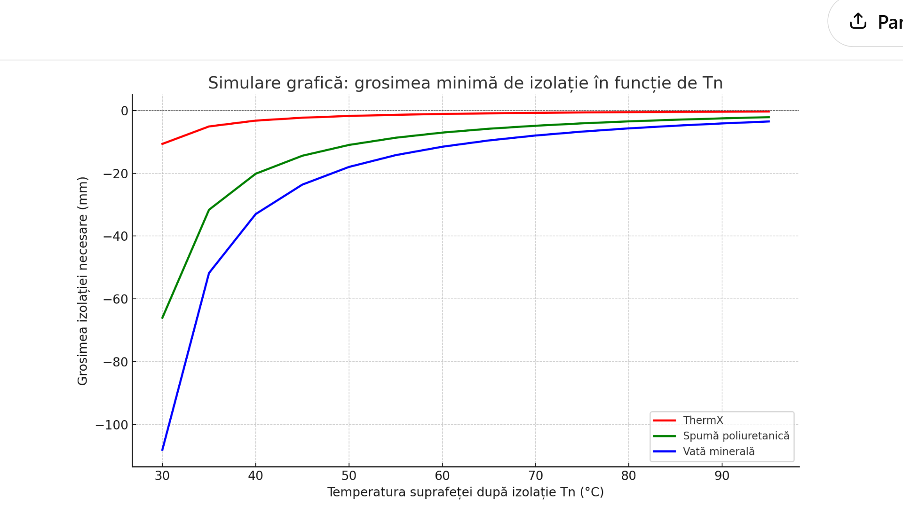
Surface temperature after insulation Tn (°C)
Required insulation thickness (mm)

This is a graphical simulation of the required insulation thickness (in millimeters) depending on the surface temperature of the pipe after applying the insulation (Tn), for three materials:
- ThermX (red)
- Polyurethane foam (green)
- Mineral wool (blue)
It can be observed that ThermX requires a much thinner layer compared to the other two materials under the same temperature conditions, confirming its superior thermal efficiency.

ThermX is applied to the pipe both as an anti-corrosion coating and as thermal insulation.
In our example, it should reduce the pipe surface temperature to acceptable values for the subsequent application of polyurethane foam.

Taking into account that the pipe surface may have a roughness of up to 0.15 mm, we will apply a 0.6 mm layer of ThermX to ensure high-quality coverage.
Formula for calculating the ThermX insulation layer thickness:
$$δ_{ThermX}=\frac{λ_{ThermX} ⋅\left(T_{H}-T_{n}\right)}{α_{ThermX}⋅\left(T_{n}​-T_{o}\right)}$$
where:
$δ_{ThermX}$​ = ThermX insulation thickness (in meters)
$λ_{ThermX}$​ = thermal conductivity of ThermX (W/m·°C)
T_{H}​ = temperature of the thermal agent (inside the pipe) (°C)
T_{n}​ = outer surface temperature after applying ThermX (°C)
T_{o} = ambient air temperature (°C)
α_{ThermX}​ = thermal radiation transfer coefficient of ThermX (W/m²·°C)

As can be seen under the specified conditions, the unknown in this equation is the surface temperature after applying a 0.6 mm ThermX layer.
Rewriting the formula:
$$δ_{ThermX}=\frac{λ_{ThermX} ⋅\left(T_{H}-T_{n}\right)}{α_{ThermX}⋅\left(T_{n}​-T_{0}\right)}$$

Given data:
$$0,0006=\frac{0,001 ⋅\left(150-T_{n}\right)}{2,5⋅\left(T_{n}​-25\right)}$$

Step-by-step solution:
Cross-multiply:
0,0006⋅2,5(T_{n}​−25)= 0,001(150−T_{n}​)
0,0015(T_{n} −25)= 0,001(150− T_{n} ​)
0,0015 T_{n} ​−0,0375= 0,15−0,001 T_{n} ​
Add 0,001T_{n}​ to both sides:
0,0025T_{n}​−0,0375= 0,15
Add 0,0375:
0,0025T_{n}​= 0,1875
Solve T_{n}:
$$T_{n}=\frac{0,1875}{0,0025}=75°C$$

The surface temperature of the pipe after applying a 0.6 mm ThermX layer is 75°C, which is acceptable for applying polyurethane foam (PUF), as it is below the thermal degradation limit of the foam.

COST SAVINGS
- Reduced labor and application time thanks to the simplicity and ease of using ThermX
- Savings on pipe repair costs after the warranty period due to no need to dismantle old insulation or perform extensive prep work
- Lower thermal energy costs in pipes, steam boilers, etc., due to ThermX’s excellent insulation and ability to cover valves, elbows, joints—even in hard-to-reach areas
- Can be applied directly to hot surfaces without shutting down the heating network or steam boiler
- Lower installation costs due to reduced technological steps during insulation work
- Emergency repair costs are reduced because crack detection is faster and the old insulation doesn’t need removal
- Fewer insulation repairs thanks to longer warranty periods than conventional materials
- No cost for insulation restoration—ThermX does not require reapplication after small interventions
OTHER APPLICATIONS OF THERMX
ThermX is used in construction not only as thermal insulation, but also as a waterproofing material. The latex in its composition ensures low water absorption.
Its ability to protect against condensation in apartments ensures effective frost protection and helps eliminate fungal or mold growth.

VAPOR PERMESABILITY OF ThermX
ThermX exhibits a low vapor permeability coefficient. Therefore, it is essential to evaluate whether this characteristic may impede moisture vapor diffusion from the interior wall layers to the exterior, particularly since vapor permeability resistance should ideally decrease progressively from the interior to the exterior in multilayer wall assemblies.

ADVANTAGES OF THERMX COMPARED TO STANDARD INSULATIONS
- High resistance to extreme weather and temperature variations
- Excellent resistance to solar UV radiation
- Extremely low thermal conductivity
- Long-lasting - 20-year warranty, lifespan over 35 years
- Strong adhesion to various surfaces
- Corrosion and water resistant
- Wide operating temperature range: -60 °C to +230 °C
- Quick and simple installation
- Easy to repair and inspect
- Resistant to mechanical damage
- Suitable for pipes/structures with complex shapes or hard-to-reach areas
- Eco-friendly and fire-resistant
- 30% lower cost compared to traditional insulation systems
- Up to 80% faster installation time compared to classic insulation methods
MOST EFFICIENT APPLICATION AREAS FOR THERMX:

Thermal insulation for roofs: Bituminous, ceramic, metal, basalt, cement/fiber-cement, slate, glass, wood, EPDM and PVC membranes;

Interior wall insulation: Over finishing, under plaster, on ceramic surfaces;

Exterior insulation: Architectural facades (historic buildings), structural elements, ceramic walls, partition walls, under/over plaster, on finished walls;

Ceiling insulation: Historic decorative ceilings, under/over plaster, OSB panels, false ceilings, wood, PVC, glass;

Floor insulation: Bituminous, acrylic/composite, ceramic, metal, basalt, cement/fiber-cement, slate, glass, wood, EPDM/PVC membranes;

HVAC and plumbing systems: Fittings, external pipes (liquid/steam/gas), heating system pipes, steam/gas pipelines, thermal plants, substations, cold water pipes (for condensation prevention), inspection chambers, plumbing fixtures (water/steam/gas), hydrants, boilers, steam tanks, heat exchangers, HVAC ducts;

Pools, tanks, and containers: Indoor/outdoor pools, saunas, ovens, tanks and containers, industrial tubs, silos;

Utility and commercial vehicles: Cars, refrigerated trucks, trailers, railcars/trams, buses, armored vehicles, fire trucks, cargo and passenger vehicles, military vehicles, aerospace equipment;

Industrial buildings: Refrigeration/freezing systems, technical rooms, warehouses, workshops, crane beams, hangars, garages, bridge undersides (adds strength and reduces freezing).

